

College of Behavioral & Community Sciences

Interdisciplinary Center for Evaluation and Intervention (ICEI)

Phone: (813) 974-0968 • FAX: (813) 905-9836

**Directions to the ICEI Clinic of USF**

We are located in a large complex on the southeast corner of Fletcher Avenue and Bruce B. Downs Blvd.

Address Information:

* Use the following address: 3266 USF Banyan Circle, Tampa, FL 33613. This should take you close to our parking lot (38G)
* Please feel free to call us when you get to USF and we will help to guide you in
* Below is a Map of our area. The yellow star indicates where you will park. Further details in following pages

Enter USF Banyan Circle from Fletcher Avenue: 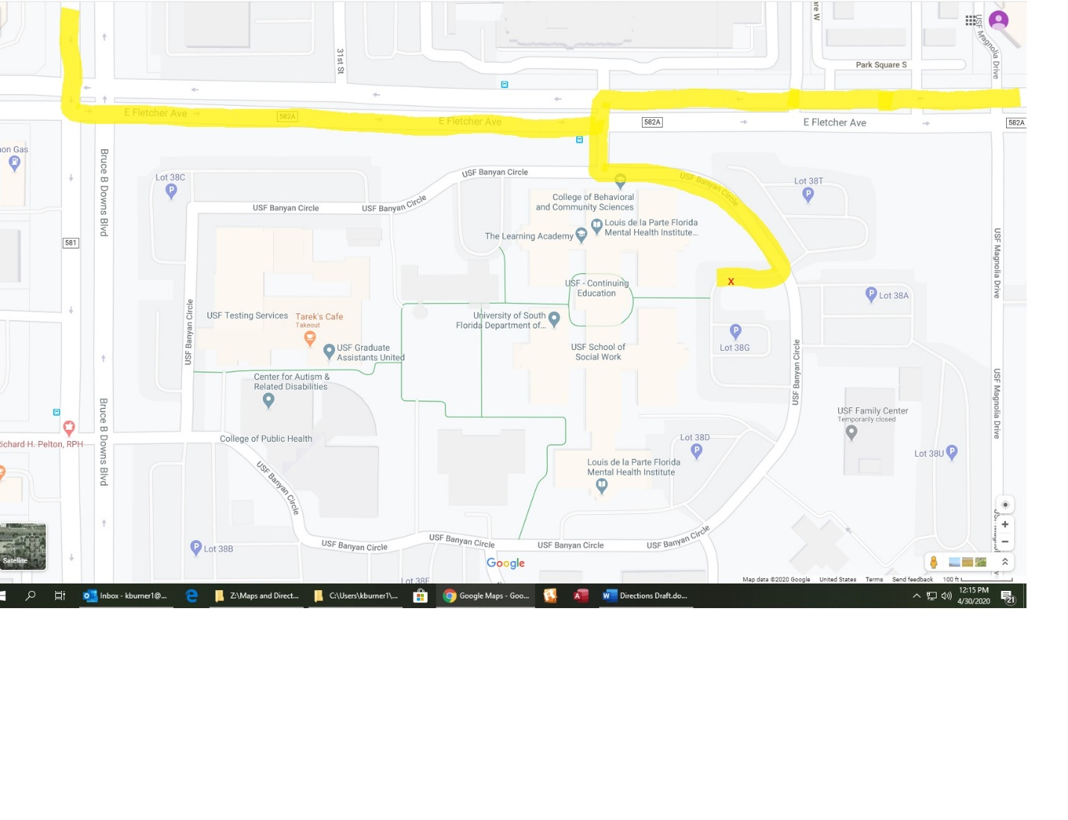Turn onto USF Banyan Circle from Fletcher Avenue

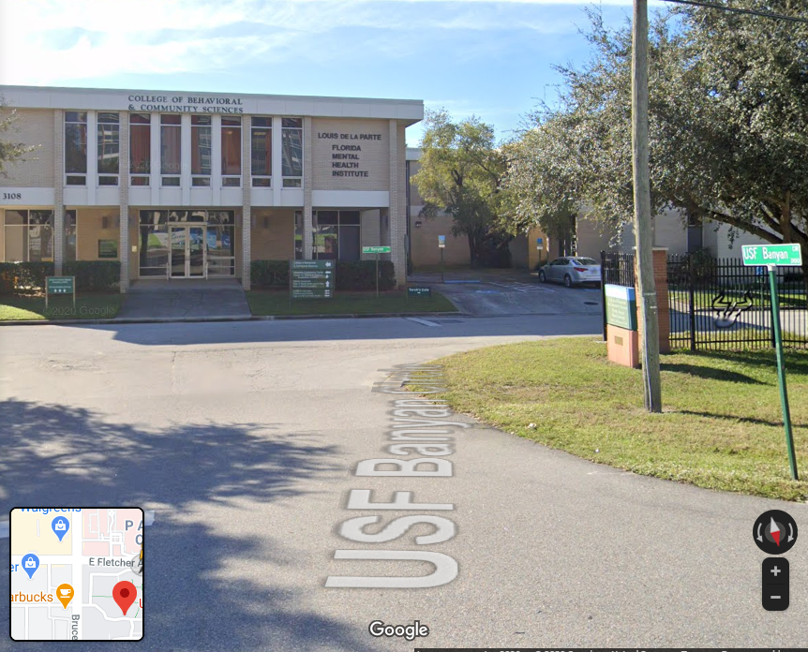

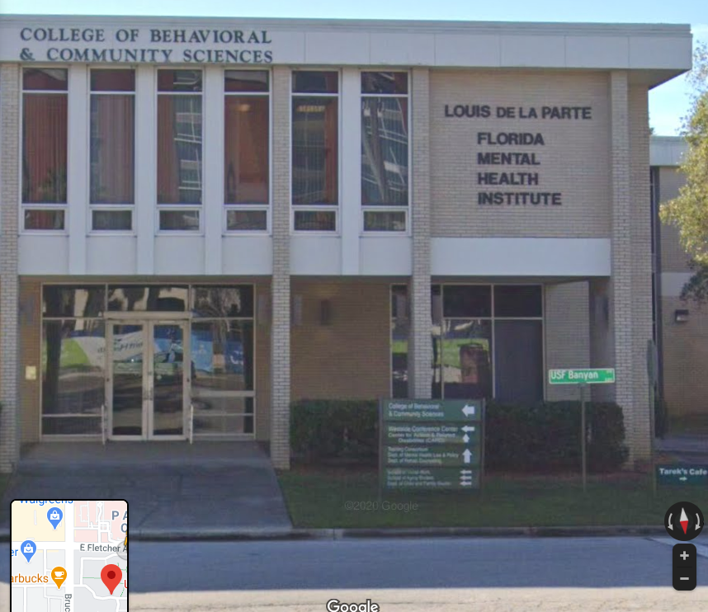

After turning onto USF Banyan Circle, turn left (you will see the building above **this is not our building**, it is just the building you will see when you turn onto Banyan from Fletcher – you can only go left or right. Go left).

Follow USF Banyan Circle until you come to parking lot **38 G** on your right– it will only be about 500 feet further. Parking lot **38G** has our clinic parking spot and will be **the first parking lot on your right** (see picture on next page).

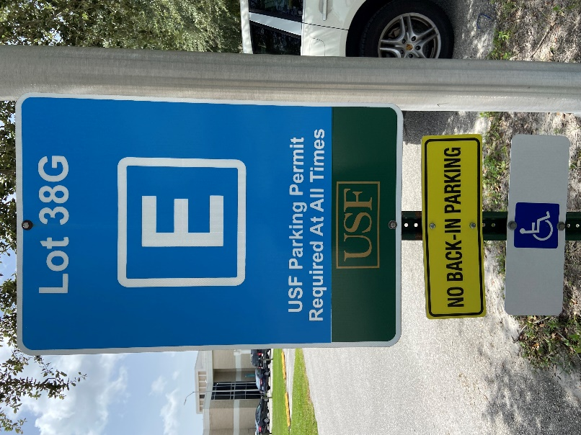

After you take a right into lot 38G, you will find our clinic parking spot. It is the **5th parking spot on the left** after you turn into the lot. Our spot is marked: **38G187.** Please only park in this middle spot marked for ICEI. Parking in any other spot could result in a parking ticket.

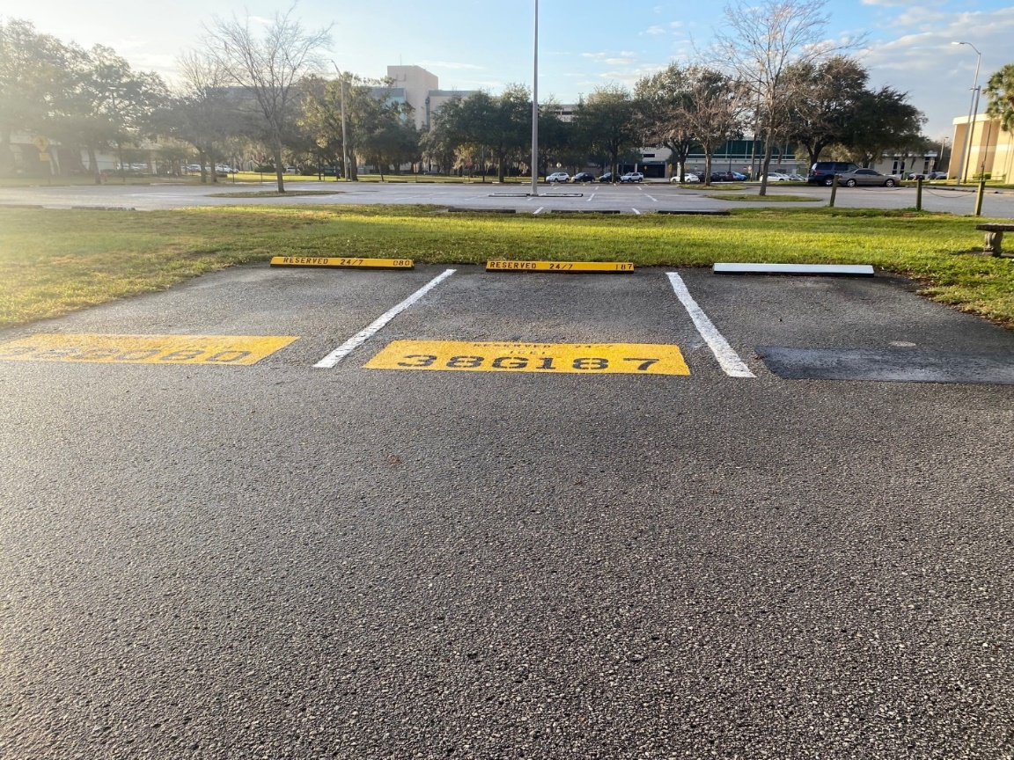

Here is a close-up view of our parking spot

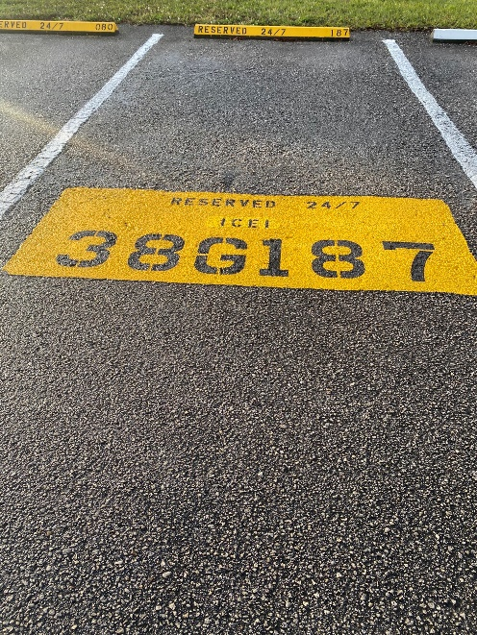 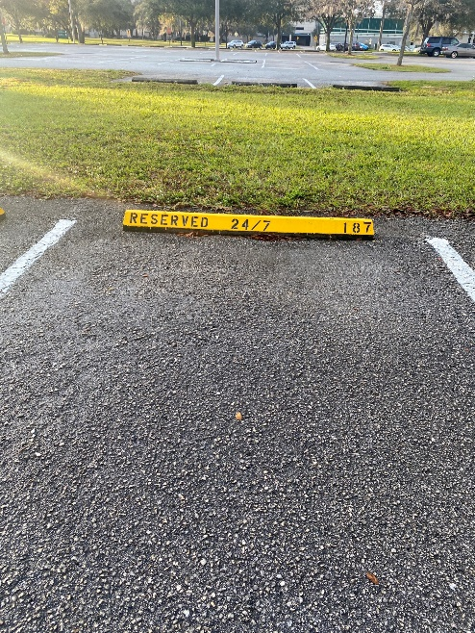

* **Once you have parked, you can call the clinic and we can help guide you to the office (813-974-0968)**
* **You may also watch this video to help you find the parking spot and clinic:**

[**https://youtu.be/GMI0fXz51HA**](https://youtu.be/GMI0fXz51HA)

* **We will take your temperature and conduct a COVID screening once you get to the clinic**